# Assignment 2, 3x3 puzzle solving code

My code assumes the blank space as zero and you have to insert the initial state and the final state at the start of the code.

How to insert the initial state and final state is described below:

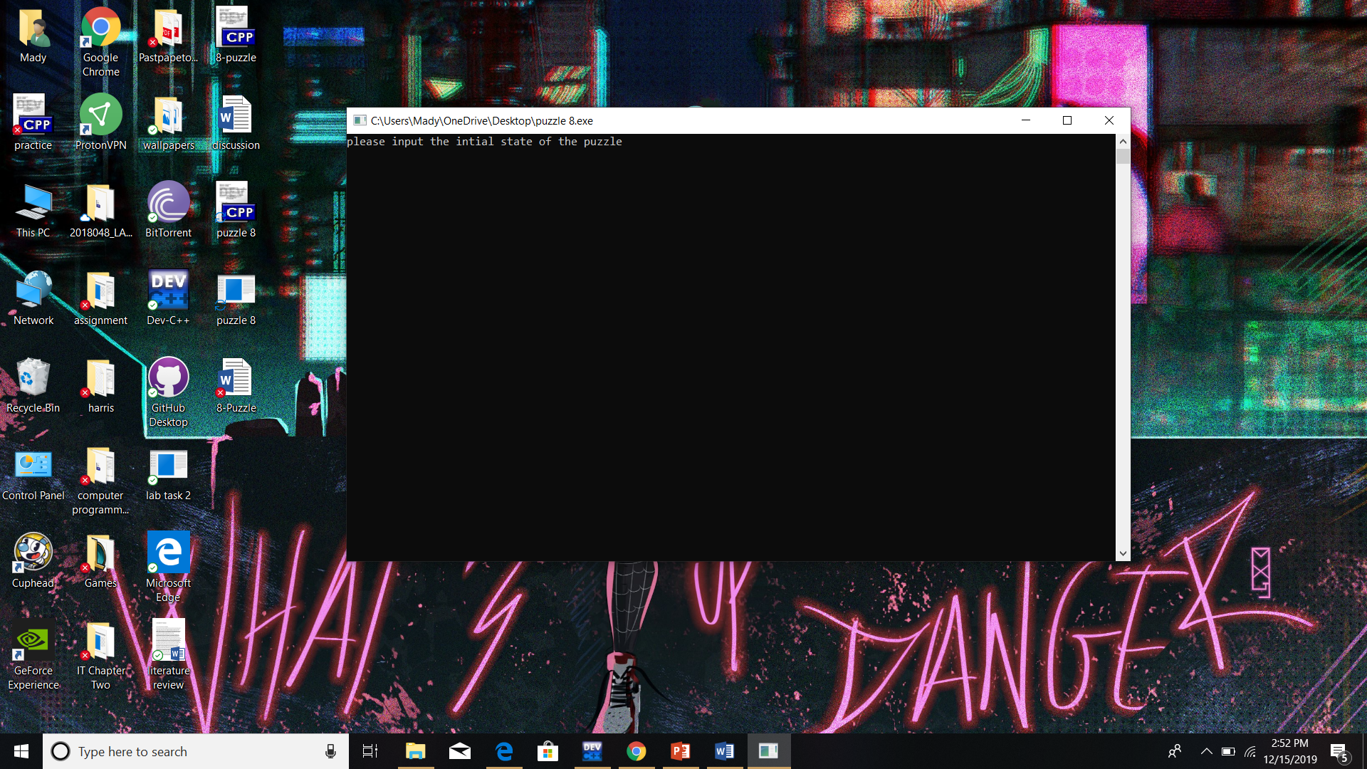

My code assumes that each puzzle you insert is solvable and it is not always the case that every puzzle is solvable. Thus we will use the left hand puzzle and insert it into my code.

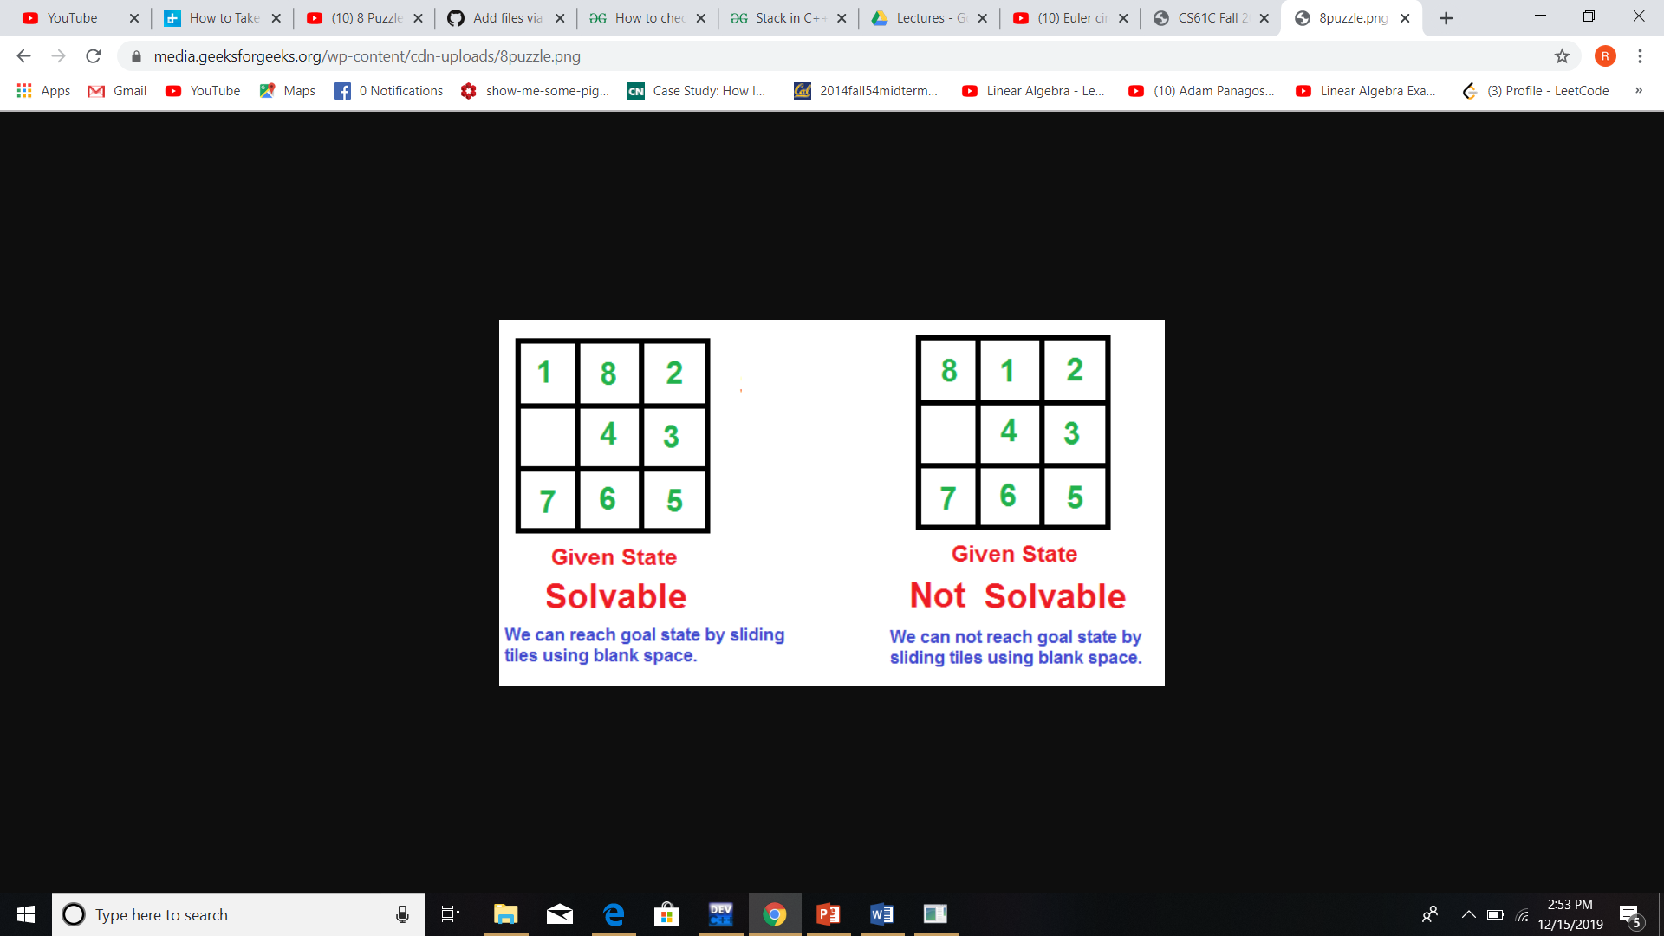

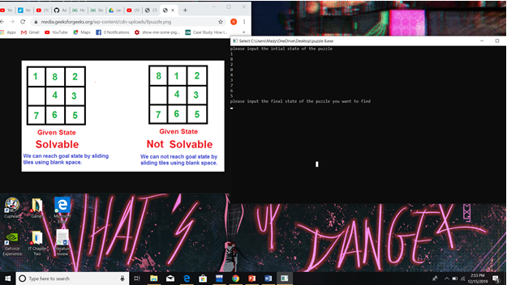Now we will insert the final state.

My code will produce all the states that led to the final state

